Name: Stuti Sehgal
Sap ID: 500107063
Batch No. :2
Lab Exercise 11– Creating a VPC in Terraform
Objective:
Learn how to use Terraform to create a basic Virtual Private Cloud (VPC) in AWS.
Prerequisites:
- Terraform installed on your machine.
- AWS CLI configured with the necessary credentials.
Steps:
- Create a Terraform Directory:
mkdir terraform-vpc
cd terraform-vpc
- Create Terraform Configuration Files:
- Create a file named main.tf:

# vpc.tf

resource "aws_vpc" "gfg-vpc" {
cidr_block = "10.0.0.0/16"
}

resource "aws_subnet" "gfg-subnet" {
vpc_id = aws_vpc.gfg-vpc.id
cidr_block = "10.0.1.0/24"

tags = {
Name = "gfg-subnet"
}
}

resource "aws_internet_gateway" "gfg-gw" {
vpc_id = aws_vpc.gfg-vpc.id

tags = {
Name = "gfg-IG"
}
}

resource "aws_route_table" "gfg-rt" {
vpc_id = aws_vpc.gfg-vpc.id

route {
cidr_block = "0.0.0.0/0"
gateway_id = aws_internet_gateway.gfg-gw.id
}

tags = {
Name = "GFG-Route-Table"
}
}

resource "aws_route_table_association" "gfg-rta" {
subnet_id = aws_subnet.gfg-subnet.id
route_table_id = aws_route_table.gfg-rt.id
}

resource "aws_security_group" "gfg-sg" {
name = "my-gfg-sg"
vpc_id = aws_vpc.gfg-vpc.id

ingress {
description = "TLS from VPC"
from_port = 20
to_port = 20
protocol = "tcp"
cidr_blocks = ["0.0.0.0/0"]
ipv6_cidr_blocks = ["::/0"]
}

egress {
from_port = 0
to_port = 0
protocol = "-1"
cidr_blocks = ["0.0.0.0/0"]
ipv6_cidr_blocks = ["::/0"]
}

tags = {
Name = "my-gfg-sg"
}
}
In this configuration, we define an AWS provider, a VPC with a specified CIDR block, and two subnets within the VPC.
- Initialize and Apply:
- Run the following Terraform commands to initialize and apply the configuration:
terraform init
terraform apply
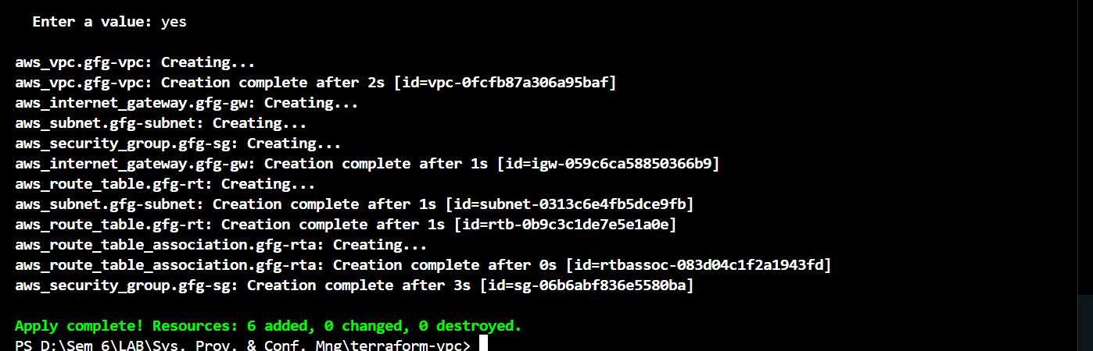
- Terraform will prompt you to confirm the creation of the VPC and subnets. Type yes and press Enter.
- Verify Resources in AWS Console:
- Log in to the AWS Management Console and navigate to the VPC service.
- Verify that the VPC and subnets with the specified names and settings have been created.
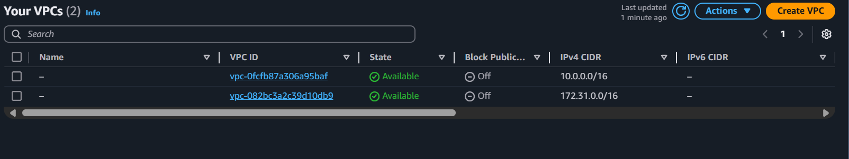
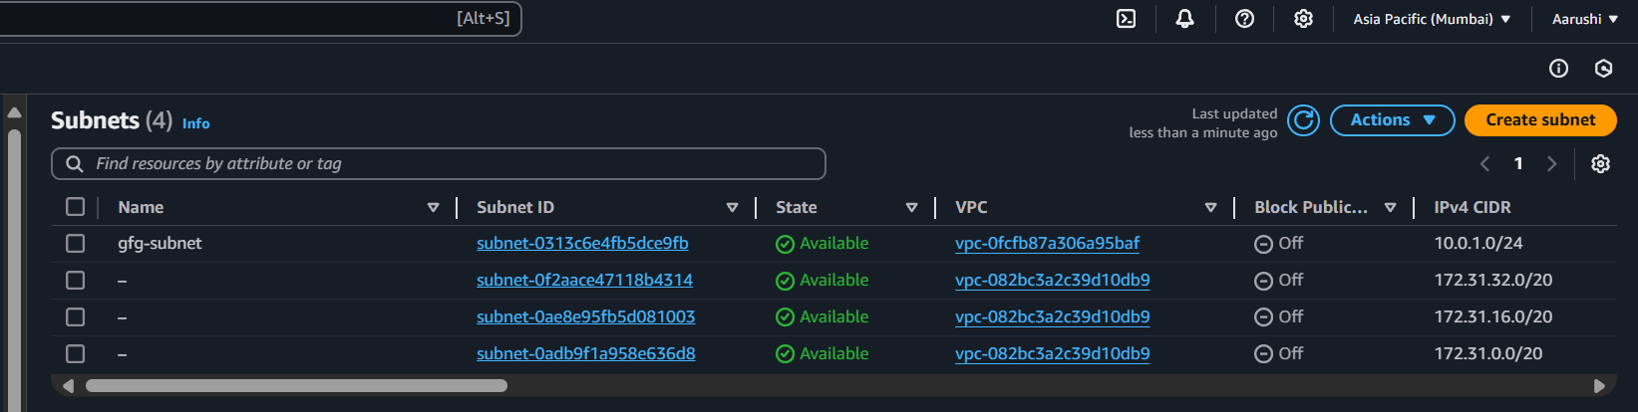
- Update VPC Configuration:
- If you want to modify the VPC configuration, update the main.tf file with the desired changes.
- Rerun the terraform apply command to apply the changes:
terraform apply


- Clean Up:
After testing, you can clean up the VPC and subnets:
terraform destroy
Confirm the destruction by typing yes.
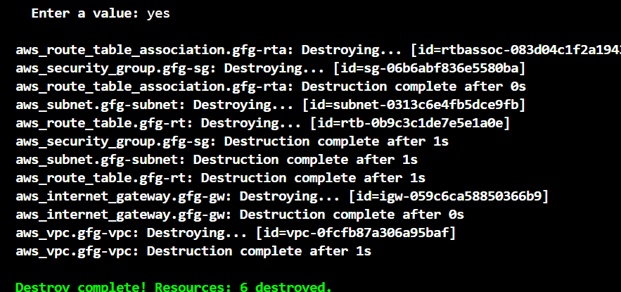
- Conclusion:
This lab exercise demonstrates how to create a basic Virtual Private Cloud (VPC) with subnets in AWS using Terraform. The example includes a simple VPC configuration with two subnets. Experiment with different CIDR blocks, settings, and additional AWS resources to customize your VPC.

